**Financial analysis of banks**

1.INTRODUCTION

1.1Overview

Financial analysis is the process of examining a company’s performance in the context of its industry and economic environment in order to arrive at a decision or recommendation. Often, the decisions and recommendations addressed by financial analysts pertain to providing capital to companies—specifically, whether to invest in the company’s debt or equity securities and at what price. An investor in debt securities is concerned about the company’s ability to pay interest and to repay the principal lent. An investor in equity securities is an owner with a residual interest in the company and is concerned about the company’s ability to pay dividends and the likelihood that its share price will increase.

Overall, a central focus of financial analysis is evaluating the company’s ability to earn a return on its capital that is at least equal to the cost of that capital, to profitably grow its operations, and to generate enough cash to meet obligations and pursue opportunities.

1.2 Purpose

The goal of financial analysis is to analyse whether an entity is stable, solvent, liquid, or profitable enough to warrant a monetary investment. It is used to evaluate economic trends, set financial policy, build long-term plans for business activity, and identify projects or companies for investment.

2.Problem Definition & Design Thinking

2.1 Empathy Map



2.2 Ideation & Brainstorming Map



**3.RESULT**

**DASHBOARD 1**

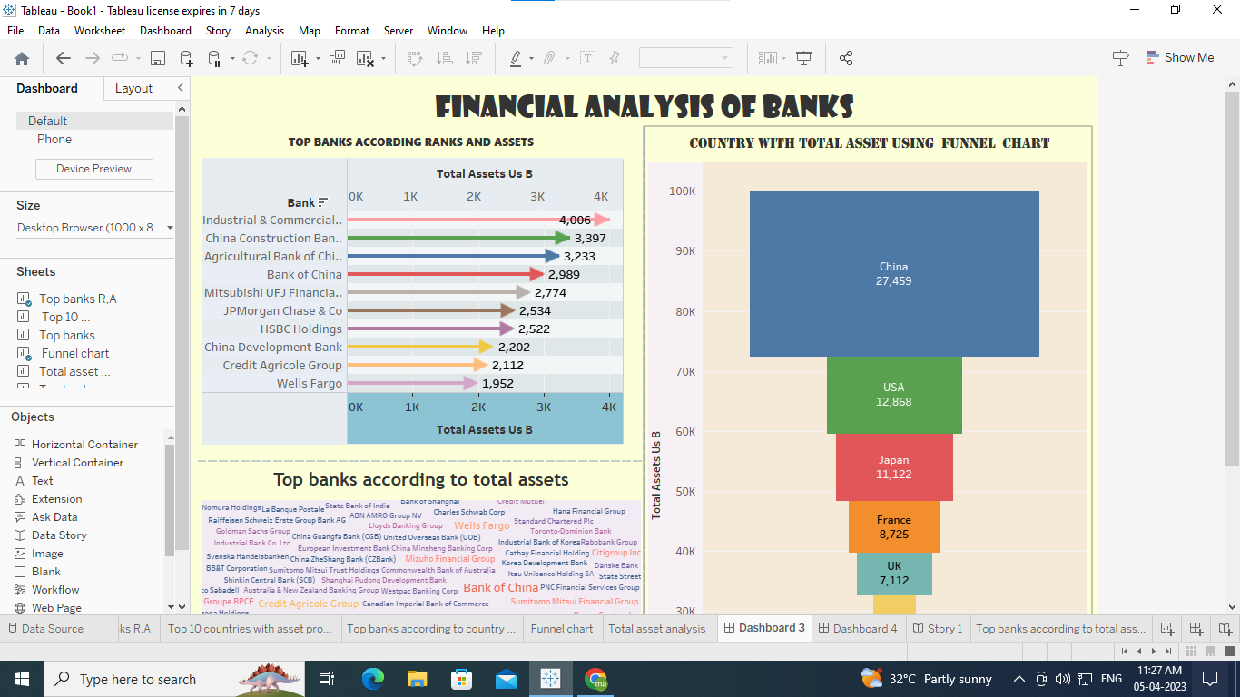

**DASHBOARD 2**

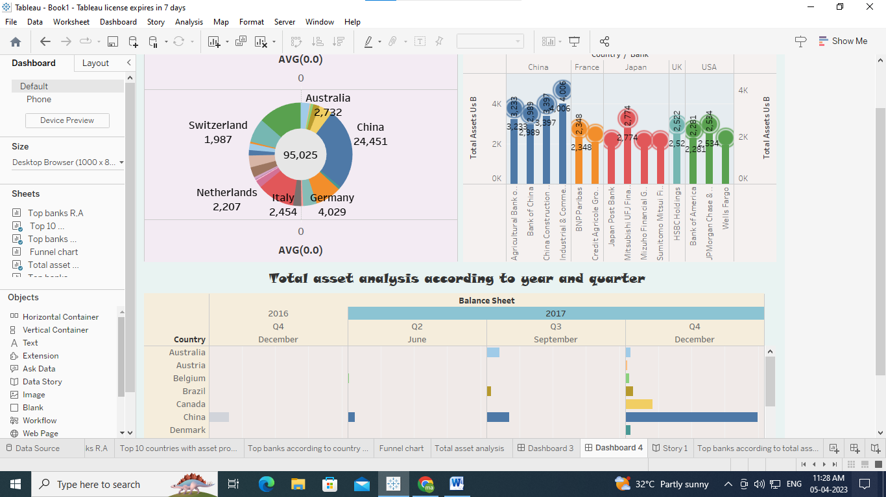

**STORY**

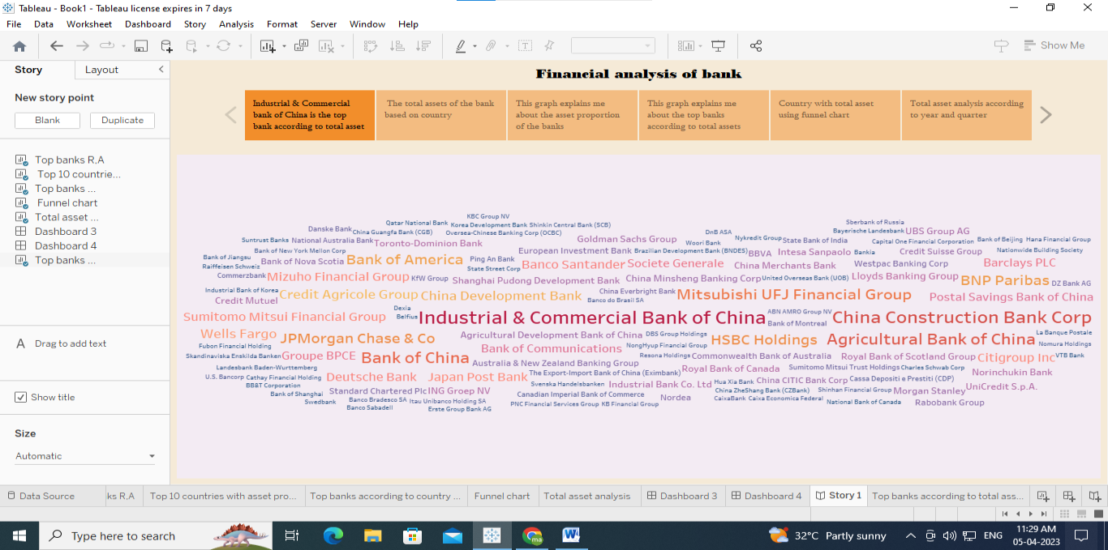

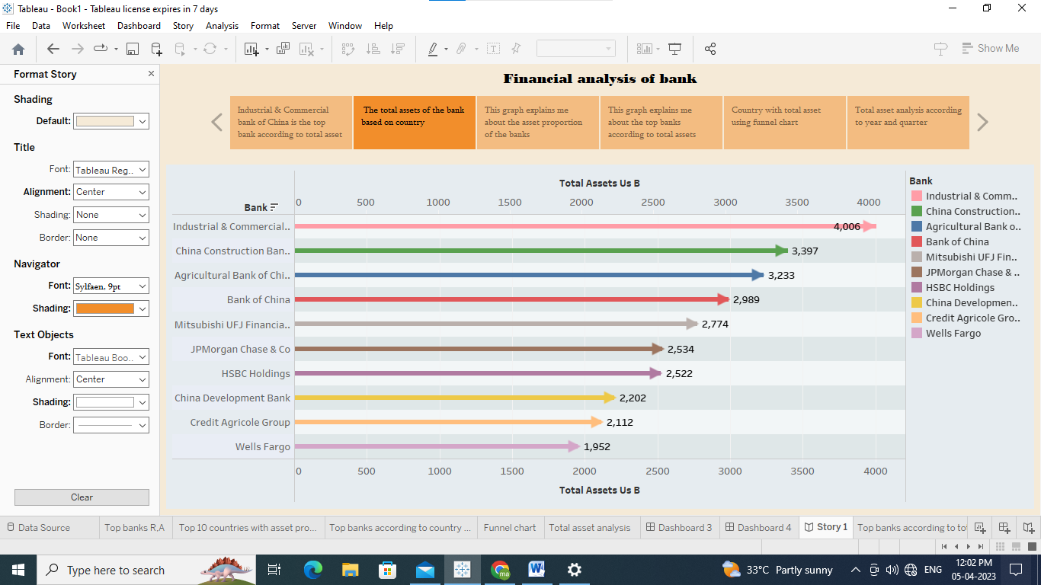

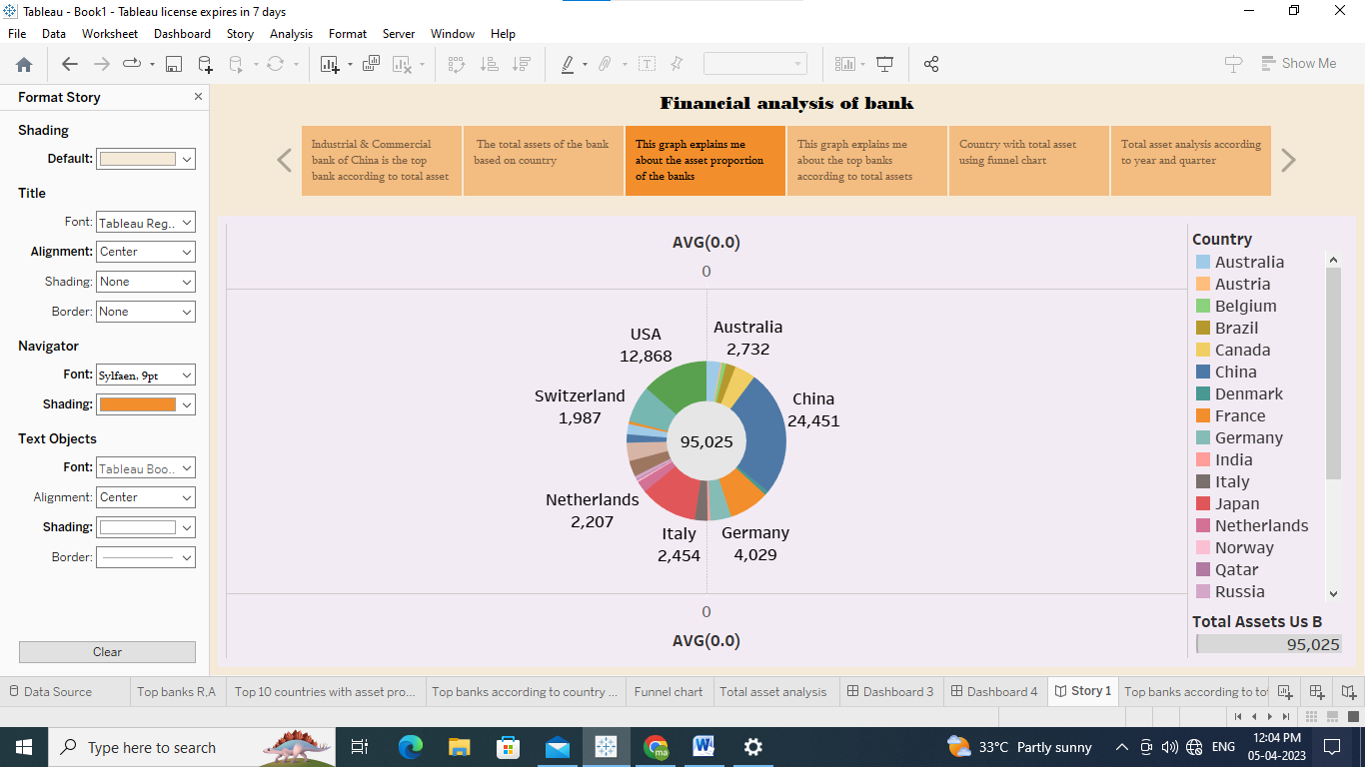

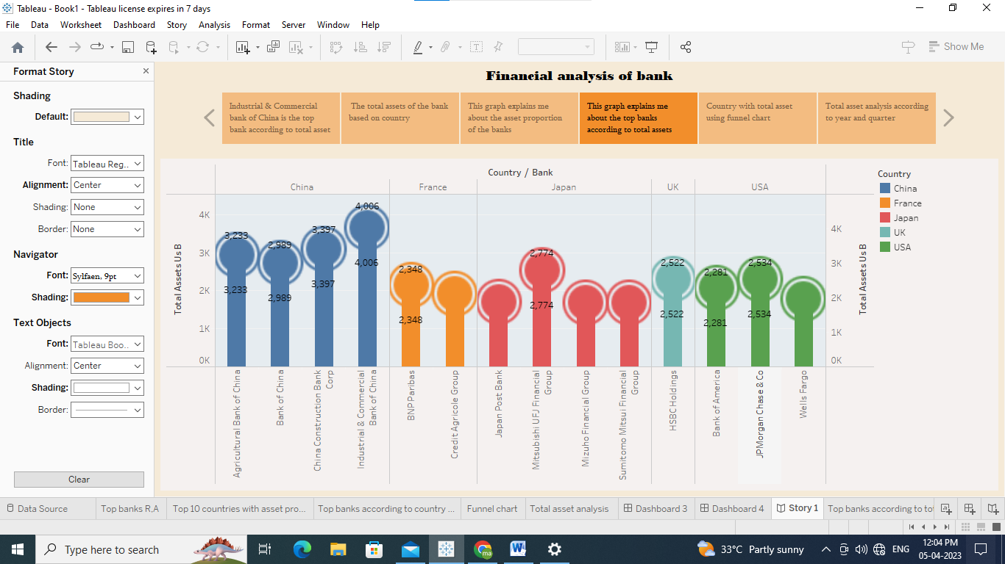

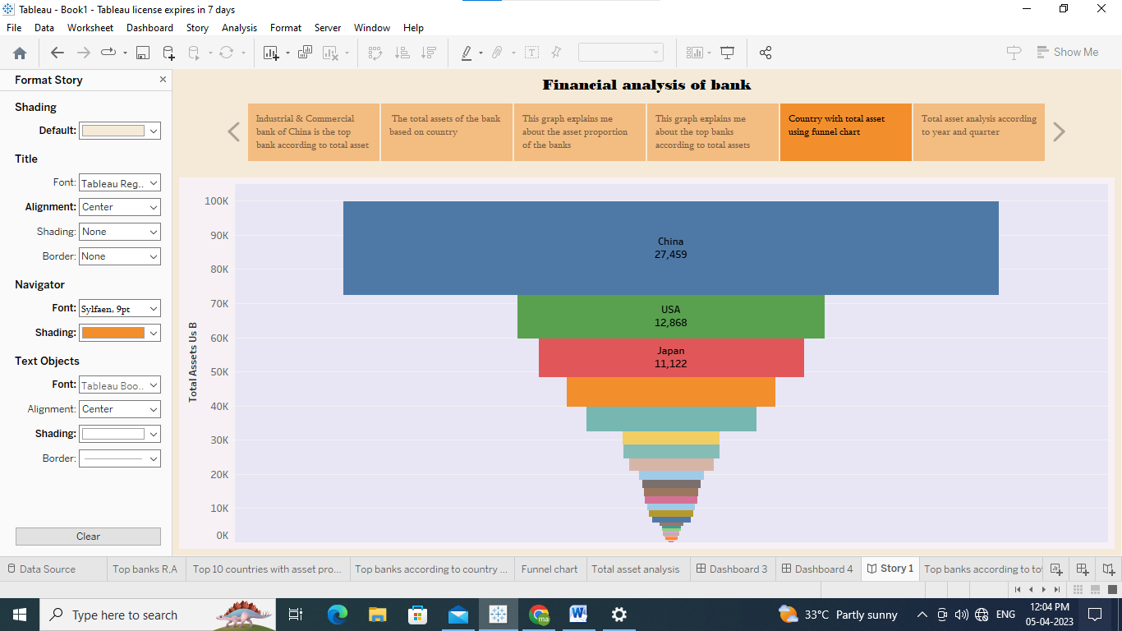

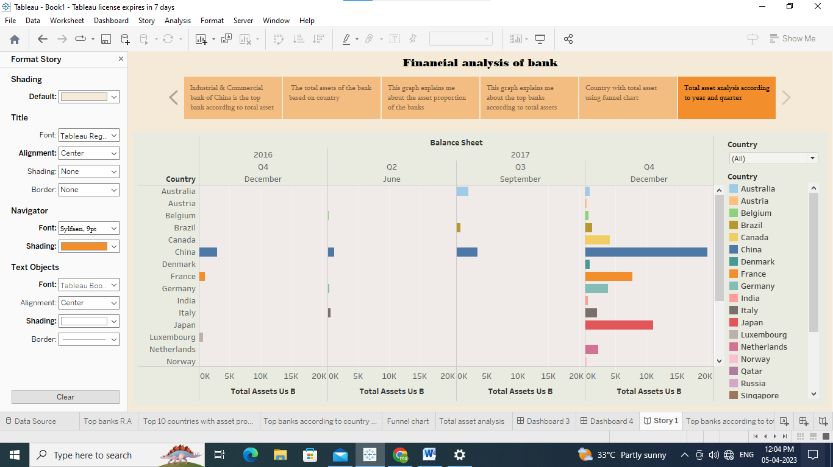

**4.ADVANTAGES & DISADVANTAGES**

* To stay safe and protect people's deposits,
* lower the probability of bank failures
* Helps in Providing funds for development of backward areas
* Raising long term capital.
* Channelization of funds in a proper way
* Adequate capital is critical to protect financial institutions’ depositors and policyholders
* The drawback would be that during economic turmoil like inflation and liquidity traps
* Capital adequacy cannot measure expected losses, which, in turn, can dent the bank’s capital.

5. APPLICATIONS

The banking sector is considered to as the backbone of the Indian economy and offers various career opportunities to students. It is one of the lucrative careers especially for the people who are looking job in government sector. The sector is in the huge need for manpower .They are taking banking to remote areas also by opening new branches. It is also considered one of the socially respectable and secure job

6. CONCLUSION

We learned about the top banks according to total assets using different charts**.** It provides financial information such as the company's asset structure, asset liquidity, source of funds, debt level, and liability structure. Thus, according to financial tools to analyse each part of financial statements is useful for avoiding financial risks.

**7. FUTURE SCOPE**

To compete, most banks will have to embrace cross-industrial platforms. These new platforms dismantle the barriers between traditional industries, reshaping customer behaviour and turning formerly linear value chains into ecosystems that fulfil customer needs in new ways. The process has already reached critical mass in industries such as healthcare, media, music, and retail, where diverse players are connected by platforms created by global leading companies that have been amply rewarded by the global capital markets. In contrast, banks have been consistently undervalued by the capital markets, making banking the lowest-valued sector in the world

8. Appendix

Source code: Fin Analytica